AMAZON APP

K.Gowthami(192224229)

AMAZON APP – BIG DATA & SUPPLY CHAIN MANAGEMENT CASE STUDY
1. About Amazon
Amazon, founded in 1994, is the world’s largest e-commerce and cloud-driven marketplace, serving hundreds of millions of customers globally. Amazon’s mission is to be Earth’s most customer-centric company, offering vast product selection, competitive pricing, and ultra-fast, reliable delivery.
Amazon processes millions of orders per day across diverse categories including electronics, fashion, groceries (Amazon Fresh), and digital services. To support this scale, Amazon relies heavily on Big Data, AI, and integrated supply chain platforms.

2. Business Challenge
As Amazon scaled rapidly, it faced significant operational complexity due to:
- Disconnected Order Management (OMS)
- Complex Warehouse/Fulfillment Systems (WMS)
- Large-scale Transportation & Last-Mile Delivery Networks (TMS)
Each system initially operated semi-independently, leading to:
- Data silos
- Delays in order fulfillment
- Inefficient inventory utilization
- Higher logistics costs
- Reduced customer satisfaction during peak demand
To solve this, Amazon built a highly integrated, in-house Supply Chain & Big Data ecosystem powered by AWS, AI, and real-time analytics.

3. Key Scale Metrics
- Launched: 1994
- Countries Served: 100+
- Products Listed: 350M+
- Daily Orders: Millions globally
- Prime Members: 200M+
- Fulfillment Centers: 1,000+ worldwide
- Delivery Partners & Employees: Millions globally

4. Core Challenges Faced by Amazon
Inefficient Order Management at Scale
Handling millions of orders per hour during peak events (Prime Day, festive sales) required real-time coordination across multiple regions.
Inventory & Fulfillment Complexity
Poor inventory visibility could lead to:
- Stockouts
- Overstocking
- Increased holding costs
- Delayed deliveries
Last-Mile Delivery Optimization
Managing diverse delivery modes (same-day, next-day, scheduled delivery) across cities and rural regions posed major logistical challenges.

5. Amazon’s Integrated Supply Chain Solution
Amazon developed a fully unified, data-driven Supply Chain Management platform, integrating:
- Order Management System (OMS)
- Warehouse Management System (WMS)
- Transport Management System (TMS)
All systems operate on real-time data pipelines, AI models, and predictive analytics.

6. Order Management System (OMS)
Centralized Order Processing
All orders from:
- Amazon website
- Mobile app
- Alexa voice shopping
are consolidated into a single intelligent OMS, reducing errors and delays.
Real-Time Order Tracking
Customers and internal teams can track orders from placement to final delivery in real time.
Order Prioritization & Smart Allocation
Orders are automatically:
- Prioritized based on delivery promise
- Assigned to the nearest fulfillment center
- Optimized for fastest delivery at lowest cost

7. Warehouse Management System (WMS)
Real-Time Inventory Visibility
Amazon’s WMS provides:
- Live stock tracking
- Demand-based replenishment
- Automated restocking decisions
Warehouse Automation
- Robotic picking (Amazon Robotics)
- AI-driven packing optimization
- Reduced human errors
- Faster order processing
Quality Control & Compliance
Automated checks ensure:
- Product authenticity
- Safety compliance
- Damage prevention

8. Transport Management System (TMS)
Route Optimization
AI models optimize delivery routes using:
- Traffic data
- Weather conditions
- Distance & delivery windows
Vehicle & Delivery Partner Tracking
Real-time GPS tracking ensures:
- Efficient fleet utilization
- Accurate ETAs
- Improved delivery reliability
Predictive Capacity Planning
Big Data models forecast:
- Peak demand periods
- Required delivery capacity
- Resource allocation for Prime events

9. Industry-Leading Customer Experience Innovations
- Same-Day & One-Day Delivery
- Prime Membership Priority Shipping
- Smart Address & Location Intelligence
- Route-Based Picking
- Hassle-Free Returns & Instant Refunds
- Amazon Lockers & Pickup Points
- Multi-Factor Authentication for Secure Deliveries

10. Big Data & Technology Stack (High Level)
- Data Ingestion: Kafka, Kinesis
- Processing: Spark, Flink
- Storage: S3, DynamoDB, Redshift
- ML Models: Demand forecasting, recommendation engines
- Cloud Platform: AWS
- Analytics: Real-time dashboards & predictive analytics

11. Impact of Amazon’s Integrated SCM Platform
Enhanced Customer Experience
- Faster deliveries
- Accurate order tracking
- High reliability → increased loyalty
Improved Operational Efficiency
- Reduced logistics cost
- Higher warehouse productivity
- Better asset utilization
Accurate Demand Forecasting
- Lower wastage
- Reduced stockouts
- Smarter inventory planning
Seamless Data Integration
OMS, WMS, and TMS operate as a single data ecosystem, eliminating silos.
Massive Scalability
Amazon can scale instantly during:
- Prime Day
- Festive sales
- Global launches

12. Objectives of the Amazon App
- Provide convenient online shopping
- Offer massive product variety
- Enable ultra-fast delivery
- Reduce physical store dependency
- Ensure secure digital payments
- Deliver personalized recommendations
- Maximize customer satisfaction

13. Stakeholders
Stakeholder | Role
Customers | Purchase products
Sellers & Vendors | Supply goods
Fulfillment Staff | Manage warehouses
Delivery Partners | Deliver orders
Admin & Ops Teams | Monitor platform
Payment Gateways | Process transactions

14. Functional Features
14.1 User Features
- User registration & login
- Product search & recommendations
- Cart & wishlist management
- Multiple payment options
- Real-time order tracking
- Reviews & ratings
- Easy returns & refunds
14.2 Admin Features
- Product & seller management
- Inventory monitoring
- Order orchestration
- Logistics analytics
- User behavior insights
- Fraud & risk monitoring

5. System Architecture Overview

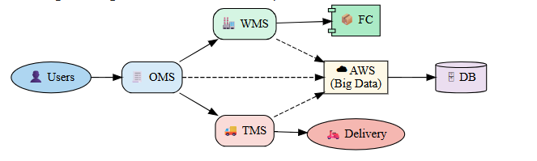

THE MAIN ARCHITECTURE OF THE AMAZON APP
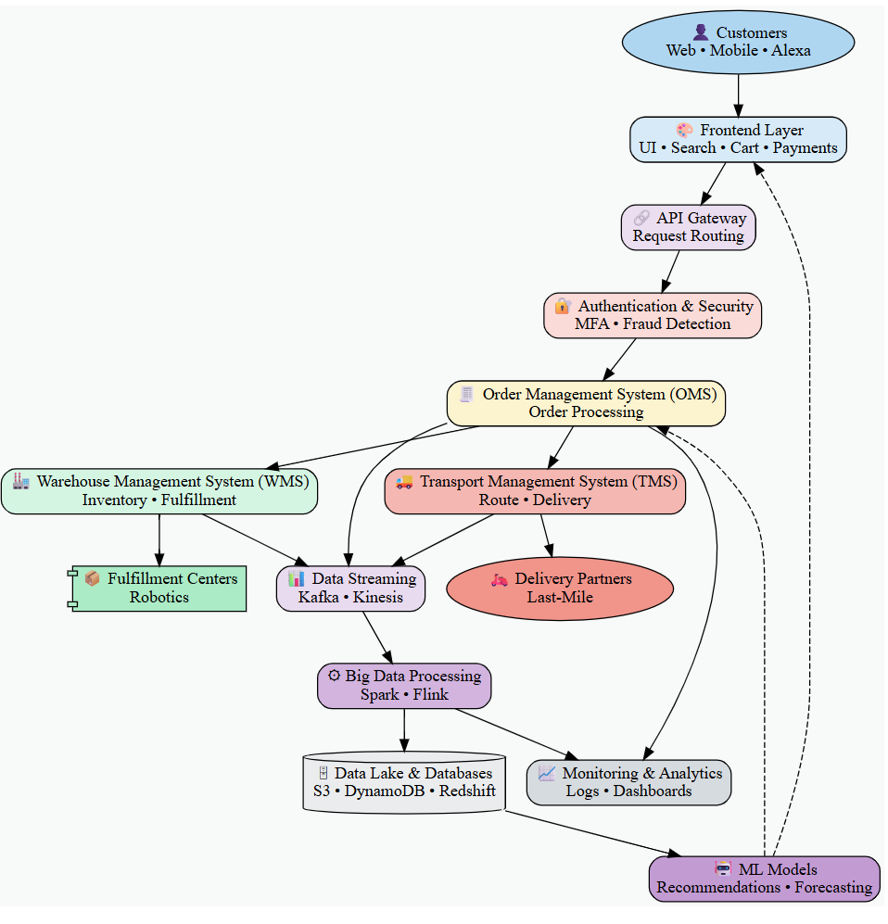
Architecture Type
- Client–Server Architecture
- Microservices-based backend architecture
- Cloud-native, globally distributed infrastructure (AWS)
Amazon uses a highly scalable microservices architecture, where each service (orders, payments, inventory, delivery, recommendations) operates independently and communicates through APIs, ensuring fault tolerance and high availability.

Main Components of the Amazon App
- Mobile Applications (Android / iOS) and Web Interface
- Backend Microservices (APIs)
- Order Management System (OMS)
- Warehouse & Fulfillment Systems (WMS)
- Delivery & Transport Management System (TMS)
- Payment Processing Systems
- Big Data & Analytics Platform

6. Database Design Summary (Amazon)
Key Entities in the Amazon Database
- User
- Address
- Product
- Category
- Cart
- Order
- Payment
- Shipment / Delivery
- Seller / Vendor
➡️ Amazon uses a hybrid database approach:
- Relational databases for transactional consistency (orders, payments)
- NoSQL databases for scalability (catalog, sessions, recommendations)
Data is designed using normalization where required and denormalization for high-speed read operations at scale.

7. Technology Stack Used (Amazon App)
Layer | Technology
Frontend | Android (Kotlin/Java), iOS (Swift), React (Web)
Backend | Java, Spring Boot, Microservices
Databases | Amazon RDS, DynamoDB, Aurora
Cloud Platform | Amazon Web Services (AWS)
Payments | Amazon Pay, UPI, Cards, Net Banking
Analytics & Big Data | Amazon Redshift, EMR, Athena, QuickSight

8. Security Features in the Amazon App
- HTTPS / SSL encryption for all data transmission
- Multi-Factor Authentication (MFA)
- Secure login & authorization mechanisms
- End-to-end encrypted payment transactions
- OTP & biometric verification
- Role-based access control (RBAC)
- API security with authentication tokens
- Fraud detection using AI models

Why Amazon’s Architecture Is Industry-Leading
- Supports millions of concurrent users
- Enables fault isolation through microservices
- Scales globally with cloud elasticity
- Integrates Big Data & AI deeply into operations
- Ensures high security and reliability

9. Supply Chain & Logistics Model

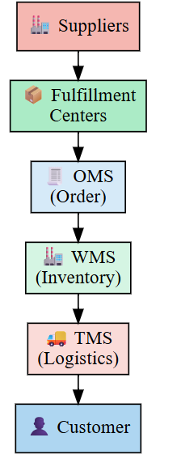
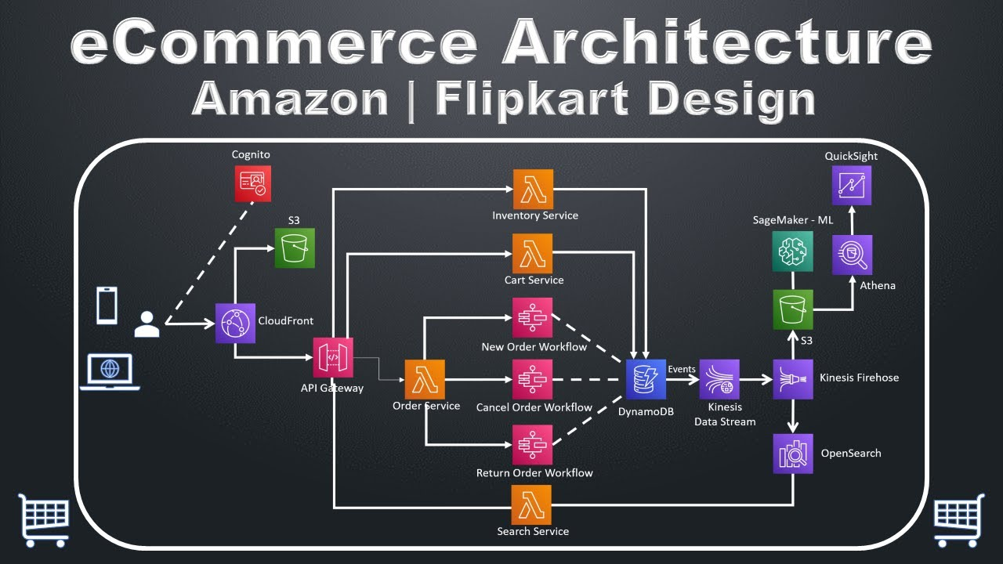

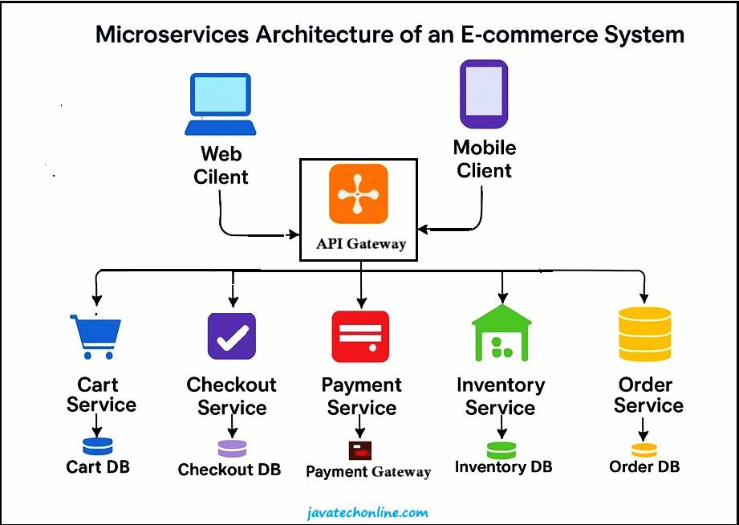

AMAZON App – Database Design Structure (ER Diagram View)

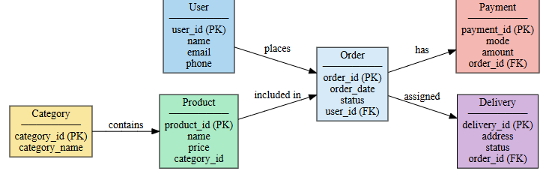

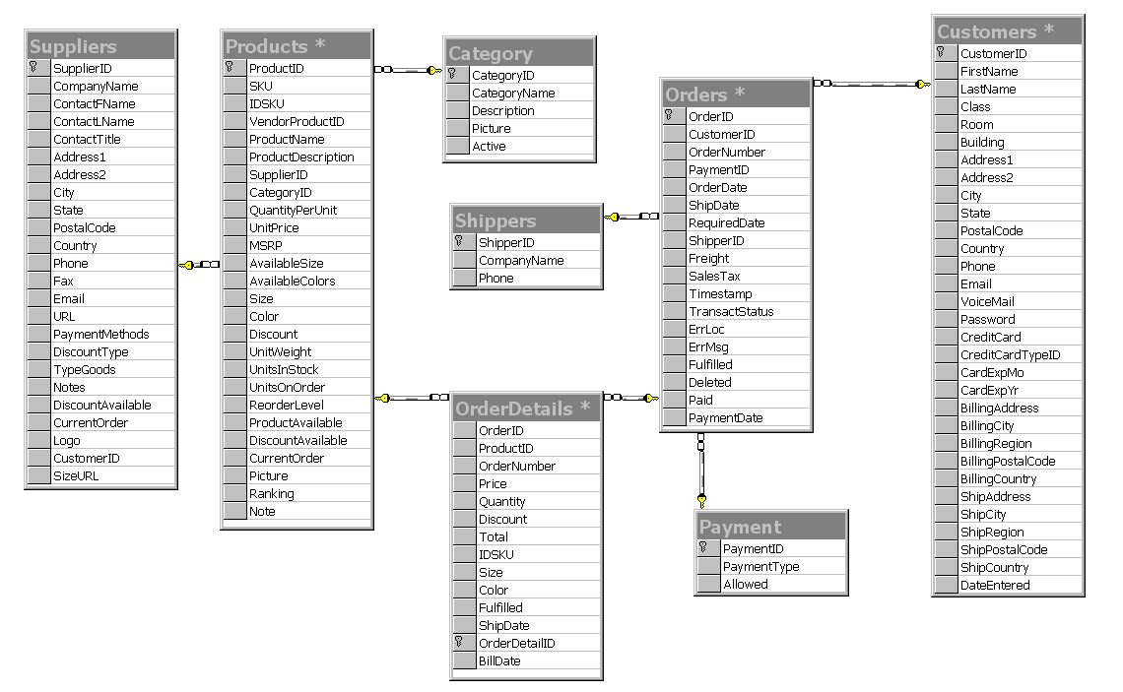
1. User
- user_id (PK)
- name
- email
- phone
- password
- role (customer/admin)
- created_at
➡️ One user can place many orders

2. Address
- address_id (PK)
- user_id (FK)
- house_no
- street
- city
- pincode
- latitude, longitude
➡️ One user can have multiple delivery addresses

3. Category
- category_id (PK)
- category_name
- description
➡️ One category can have many products

4. Product
- product_id (PK)
- category_id (FK)
- product_name
- brand
- price
- stock_quantity
- unit (kg/litre/pack)
- image_url
➡️ Products belong to one category

5. Cart
- cart_id (PK)
- user_id (FK)

6. Cart_Item
- cart_item_id (PK)
- cart_id (FK)
- product_id (FK)
- quantity
- total_price
➡️ A cart can contain many products

7. Order
- order_id (PK)
- user_id (FK)
- address_id (FK)
- order_date
- order_status
- total_amount

8. Order_Item
- order_item_id (PK)
- order_id (FK)
- product_id (FK)
- quantity
- price
➡️ One order can have many order items

9. Payment
- payment_id (PK)
- order_id (FK)
- payment_mode (UPI/Card/Wallet/COD)
- payment_status
- transaction_id

10. Delivery
- delivery_id (PK)
- order_id (FK)
- delivery_partner
- delivery_status
- expected_date

Relationship Summary (Easy to Remember)
- User → Address : 1 : N
- User → Order : 1 : N
- Category → Product : 1 : N
- Order → Order_Item : 1 : N
- Product → Order_Item : 1 : N
- Order → Payment : 1 : 1
- Order → Delivery : 1 : 1

- AMAZON APP – SYSTEM ARCHITECTURE & TECHNOLOGY STACK

- 1. Frontend (Mobile & Web)
Purpose | Tools / Technologies
Android App | Java, Kotlin
iOS App | Swift
Web Application | HTML, CSS, JavaScript
UI Frameworks | Android SDK, iOS UIKit, React
Design Standards | Material Design, Apple HIG, Amazon Design System
- 📌 Provides seamless shopping experience across mobile and web platforms.

- 2. Backend / Server Side
Purpose | Tools / Technologies
Backend Framework | Java, Spring Boot
API Development | RESTful APIs
Architecture | Microservices-based
Service Management | Spring Cloud
Authentication | OAuth 2.0, JWT
Business Logic | Java-based distributed services
- 📌 Ensures scalability, fault tolerance, and high availability.

- 3. Database & Data Storage
Purpose | Tools / Technologies
Relational Database | Amazon Aurora (MySQL/PostgreSQL compatible)
NoSQL Database | Amazon DynamoDB
Caching | Amazon ElastiCache (Redis)
Search Engine | Amazon OpenSearch (Elasticsearch)
- 📌 Optimized for massive transactional and product data.

- 4. Cloud & Hosting Infrastructure
Purpose | Tools / Technologies
Cloud Platform | Amazon Web Services (AWS)
Storage | Amazon S3
Compute | Amazon EC2
Load Balancing | Elastic Load Balancer (ELB)
Auto Scaling | AWS Auto Scaling
- 📌 Handles millions of concurrent users globally.

- 5. Payment & Transaction Systems
Purpose | Tools / Technologies
Payment Gateways | Amazon Pay
UPI & Cards | Google Pay, PhonePe, Credit/Debit Cards
Wallets | Amazon Pay Balance
Compliance & Security | PCI-DSS Standards
- 📌 Ensures fast, secure, and reliable payments.

- 6. Logistics & Delivery Management
Purpose | Tools / Technologies
Order Tracking | GPS & Real-time Tracking
Route Optimization | Amazon Logistics Algorithms
Delivery App | Android-based Delivery Partner App
Warehouse Systems | WMS (Warehouse Management System)
Transport Systems | TMS (Transport Management System)
- 📌 Supports same-day, next-day, and scheduled deliveries.

- 7. Analytics & Business Intelligence
Purpose | Tools / Technologies
Data Analytics | Amazon Redshift
Big Data Processing | AWS Glue, EMR
Visualization | Amazon QuickSight
User Behavior Tracking | Amazon Pinpoint
Reporting | Custom BI Dashboards
- 📌 Drives personalized recommendations and demand forecasting.

- 8. DevOps & Monitoring
Purpose | Tools / Technologies
Version Control | Git
CI/CD | AWS CodePipeline
Containerization | Docker
Orchestration | Kubernetes (EKS)
Monitoring | AWS CloudWatch
Logging | ELK Stack
- 📌 Enables continuous deployment and system reliability.

- 9. Security Features
Purpose | Tools / Technologies
Secure Communication | HTTPS / SSL
Authentication | OTP, JWT
Data Encryption | AES, TLS
Access Control | Role-Based Access Control (RBAC)
Fraud Detection | AI-based Risk Analysis
- 📌 Protects customer data and transactions.

- 10. Third-Party Integrations
Purpose | Tools / Technologies
SMS & Alerts | Amazon SNS
Push Notifications | Firebase Cloud Messaging
Email Services | Amazon SES
Maps & Location | Google Maps API
- 📌 Enhances communication and delivery accuracy.

TESTING TOOLS USED IN AMAZON APP

- 1. Manual Testing
Purpose | Tools
Test Management | TestRail
Bug Tracking | JIRA
Documentation | Confluence
- ✔ UI testing, exploratory testing, UAT

- 2. Automation Testing
Purpose | Tools
Mobile Automation | Appium
Web Automation | Selenium
Test Frameworks | TestNG, JUnit
CI Automation | AWS CodeBuild
- ✔ Regression & continuous testing

- 3. Unit Testing
Platform | Tools
Backend | JUnit, Mockito
Android | Espresso
iOS | XCTest
- ✔ Ensures correctness of individual modules

- 4. API Testing
Purpose | Tools
REST API Testing | Postman
Automated API Tests | RestAssured
Load Testing | Apache JMeter
- ✔ Validates microservices reliability

- 5. Performance & Load Testing
Purpose | Tools
Load Testing | Apache JMeter
Stress Testing | LoadRunner
Monitoring | AWS CloudWatch
- ✔ Handles peak sale traffic (Prime Day)

- 6. Security Testing
Purpose | Tools
Vulnerability Scan | OWASP ZAP
Penetration Testing | Burp Suite
Mobile Security | MobSF
- ✔ Protects user data & payments

- 7. Compatibility & Device Testing
Purpose | Tools
Device Testing | BrowserStack
Cloud Devices | AWS Device Farm
OS Compatibility | Android Emulator, iOS Simulator
- ✔ Ensures cross-device consistency

- 8. CI/CD & DevOps Testing
Purpose | Tools
CI/CD | AWS CodePipeline
Container Testing | Docker
Source Control | Git
- ✔ Automated testing in pipelines

- 9. User Acceptance Testing (UAT)
Purpose | Tools
Feedback Tracking | JIRA
Beta Testing | Amazon Internal Beta
Crash Reporting | AWS CloudWatch
- ✔ Confirms business & user requirements
SECURITY ANALYSIS – AMAZON APP
Amazon follows a multi-layered security architecture to protect users, transactions, and infrastructure at massive scale.

1. User Authentication & Access Control
- Secure login using username/password + OTP
- JWT tokens for session management
- OAuth 2.0 for secure API authorization
- Role-Based Access Control (RBAC) for users, sellers, admins
✔ Prevents unauthorized access

2. Data Security & Encryption
- HTTPS / SSL for all client–server communication
- AES-256 encryption for data at rest
- TLS encryption for data in transit
- Sensitive data stored in encrypted AWS services
✔ Protects personal & financial data

3. Payment Security
- Payments handled via Amazon Pay
- PCI-DSS compliant payment processing
- Tokenization of card details
- Fraud detection using ML-based risk engines
✔ Secures online transactions

4. Application & API Security
- Secure REST APIs
- API Gateways with rate limiting
- Protection against:
  - SQL Injection
  - XSS
  - CSRF
- Continuous API validation
✔ Prevents common cyberattacks

5. Cloud & Infrastructure Security
- Hosted on AWS secure infrastructure
- IAM policies for least-privilege access
- Firewalls & Security Groups
- DDoS protection using AWS Shield
- Continuous monitoring with CloudWatch
✔ Ensures system availability & resilience

6. Monitoring, Auditing & Incident Response
- Real-time logging and alerting
- Automated threat detection
- Audit trails for all critical actions
- Quick rollback & recovery mechanisms
✔ Enables fast incident handling

7. Compliance & Privacy
- GDPR & global data protection compliance
- Regular security audits
- Secure data retention policies
✔ Maintains legal & user trust

Security Architecture Overview
